How to Install and Use Github Copilot Chat Extension on Visual Studio

A guide for developers who want to leverage the power of Github Copilot in their projects

# Introduction

Github Copilot is an AI-powered code assistant that helps you write better code faster. It can suggest code completions, refactorings, tests, documentation, and more. You can use Github Copilot in Visual Studio by installing the Github Copilot Chat extension, which allows you to chat with the AI and ask for code suggestions.

In this guide, we will show you how to install the Github Copilot Chat extension on Visual Studio and how to use it to speed up your application development. We will assume that you have Visual Studio 2022 version 17.6 or later and a Github account that is linked to Visual Studio.

# Prerequisites

* An active subscription to either [GitHub Copilot for Individuals](https://docs.github.com/copilot/overview-of-github-copilot/about-github-copilot-for-individuals) or [GitHub Copilot for Business](https://docs.github.com/copilot/overview-of-github-copilot/about-github-copilot-for-business)
* Visual Studio 2022 [version 17.6](https://learn.microsoft.com/en-us/visualstudio/releases/2022/release-history) or later installed
* [GitHub Copilot extension installed](https://learn.microsoft.com/en-us/visualstudio/ide/visual-studio-github-copilot-extension?view=vs-2022#installation-instructions) in Visual Studio
* [GitHub Copilot Chat extension installed](https://learn.microsoft.com/en-us/visualstudio/ide/visual-studio-github-copilot-chat?view=vs-2022#install-the-visual-studio-extension) in Visual Studio

# How to Install the Github Copilot Chat Extension on Visual Studio

Follow these steps to install the Github Copilot Chat extension on Visual Studio:

1. Open Visual Studio.
2. On the top bar, click on **Extensions** > **Manage Extensions.**
3. In the right hand search bar, type "**Github**" and search.
4. Click on “**Github Copilot Chat**” result and a download button will appear.  
     
   A screenshot of a computer

   Description automatically generated
5. Click on the **Download** button and wait for the extension to download.
6. Repeat with the **Github Copilot** extension.
7. Close Visual Studio. A VSIX Installer will pop-up and ask you to agree with the license terms and installation of prerequisites. Click **Modify**.  
     
   A screenshot of a computer

   Description automatically generated
8. You will get a confirmation when the modifications are complete. **Close** the pop up.  
     
   A screenshot of a computer

   Description automatically generated
9. **Open** Visual Studio.
10. Go to **View** **> Github Copilot Chat.**
11. **Sign in** with your Github account and **authorize** the extension to access your repositories.
12. You should see a chat window where you can interact with Github Copilot.  
      
    A screenshot of a computer

    Description automatically generated
13. For more information about activation and authorization, reference the “Installing the Visual Studio Extension” section here: <https://docs.github.com/en/copilot/using-github-copilot/getting-started-with-github-copilot?tool=visualstudio#installing-the-visual-studio-extension>

# How to Use the Github Copilot Extension on Visual Studio to Speed Up Application Development

Once you have installed the Github Copilot Chat extension on Visual Studio, you can use it to get code suggestions, documentation, tests, and more. Here are some examples of how you can use Github Copilot to speed up your application development:

Ask Questions in the Chat Window  
  
The chat window of Copilot Chat in Visual Studio enables you to ask your questions and see answers in the chat pane. It is usually the best way to work with Copilot on programming help and general coding questions.

1. In Visual Studio, select **View** > **GitHub Copilot Chat**.
2. In the Copilot Chat window, type a coding related question in the **Ask Copilot** text box. Press **Enter** or select **Send** to ask your question.  
   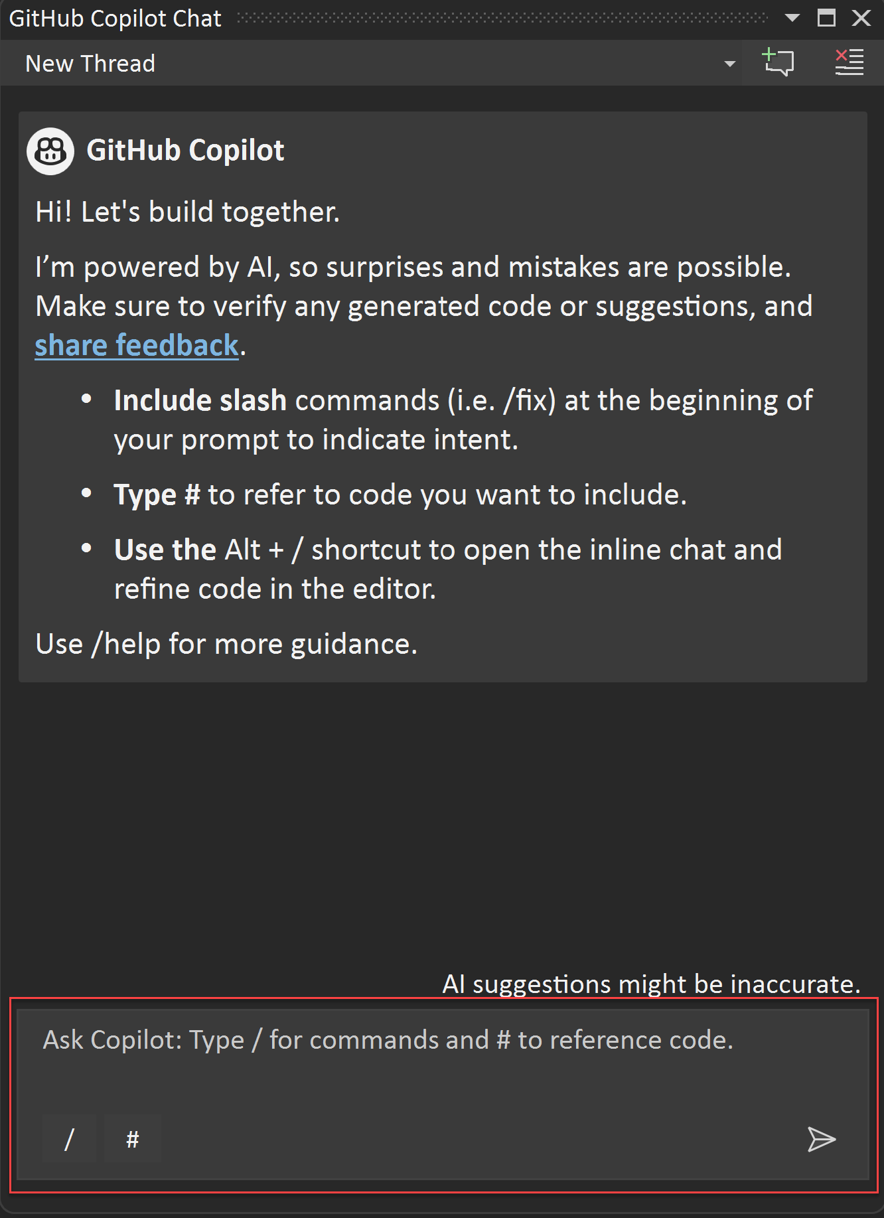
3. If Copilot Chat offers a code suggestion you want to use, select **Copy code block** to copy the code suggestion, **Insert in new files** to insert the code suggestion in a new file, or select **Preview** to insert the code suggestion in your current code file. Using the **Preview** button lets you preview the code in the target location so you can easily see what's being updated.  
     
   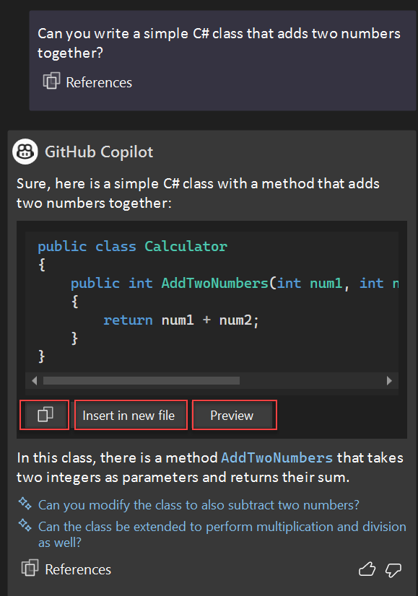
4. If you ask a question for help with understanding your code, **Copy code block** and **Insert in new file** options won't be available.
5. If you select **Preview**, you'll see the code suggestions in normal Visual Studio diff view pattern. You can review and refine what is being proposed and apply to your code by selecting **Accept** or discard by selecting **Cancel**.  
     
   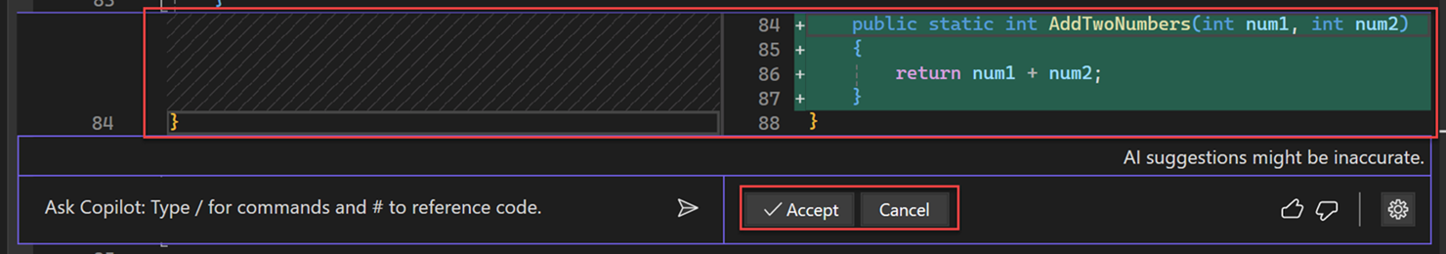
6. If you select **Insert in new file**, you'll see the code suggestions in a new file. The file is not saved by default.  
     
   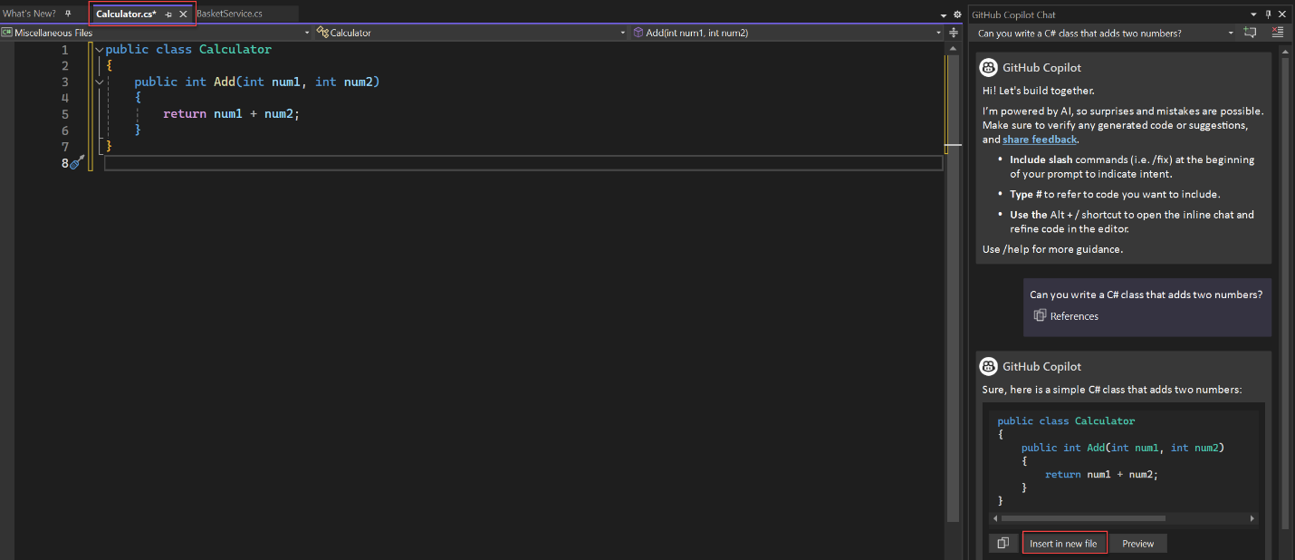

Ask Questions in the Inline Chat View  
  
The inline chat view of Copilot Chat in Visual Studio enables you to ask your questions and see answers inline with the code in the editor window itself. With inline chat, you don't have to go back and forth to the chat window. It is usually the best way to work with Copilot on questions that add to or update a currently open code file.

1. In Visual Studio, right click in your editor window and select **Ask Copilot** to bring up the inline chat view of Copilot Chat in the editor itself.  
     
   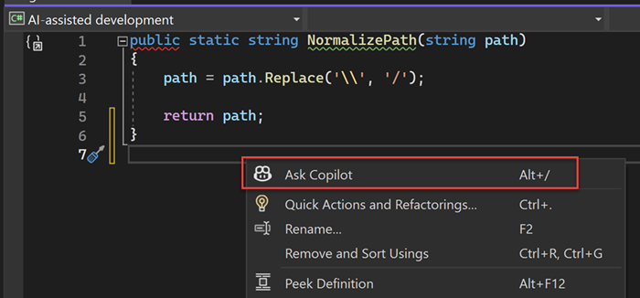
2. Type your coding related question in the **Ask Copilot** text box, and then press **Enter** or select **Send** to ask your question.  
     
   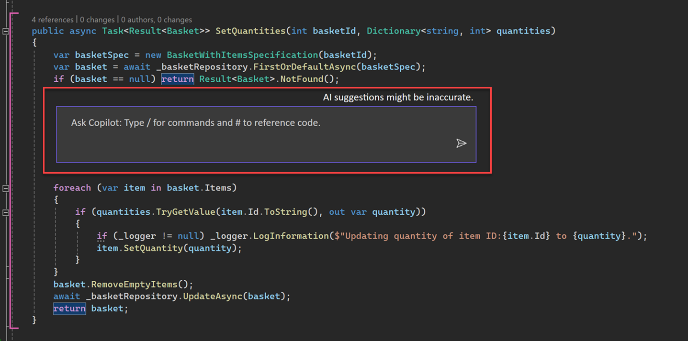
3. You'll see code suggestions from Copilot Chat in Visual Studio diff view. You can review and refine what is being proposed and apply to your code by selecting **Accept** or discard by selecting **Cancel**.  
     
   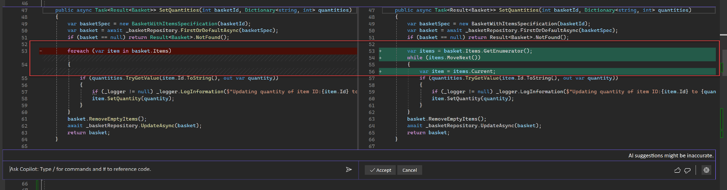
4. You can close the inline chat view by pressing **Esc**.

Use Slash Commands for Common Tasks

Slash commands in Copilot Chat help you set the intent quickly for common development tasks. By using specific slash commands to form your question, you can get better answers without having to write out long questions.

You can use slash commands in a [chat window](https://learn.microsoft.com/en-us/visualstudio/ide/visual-studio-github-copilot-chat?view=vs-2022#ask-questions-in-the-chat-window), or directly inline in the code that you're looking to modify, using [inline code assistance](https://learn.microsoft.com/en-us/visualstudio/ide/visual-studio-github-copilot-chat?view=vs-2022#ask-questions-in-the-inline-chat-view). Commands that help modify or add to the code file you have open in the editor will work both in the inline code assistant and the chat windows whereas commands for more general coding questions work only in the chat pane.  
  
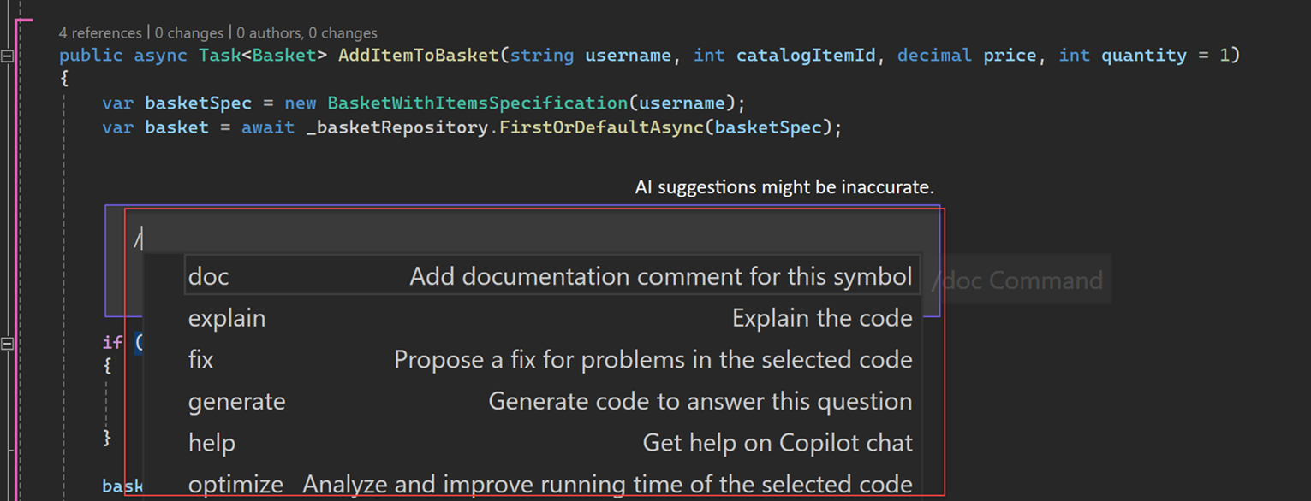  
  
Scope Copilot Results to a Particular File

You can ask your coding related questions in natural language and GitHub Copilot Chat will answer these in the context of the codebase open in Visual Studio. With references you can get more specific about the information you want Copilot to consider when answering your question. By selecting a specific context in your codebase, you're able to form better questions easily without having to write out or paste long pieces of information. Specifying the context also enables Copilot to provide you with more relevant answers.  
  
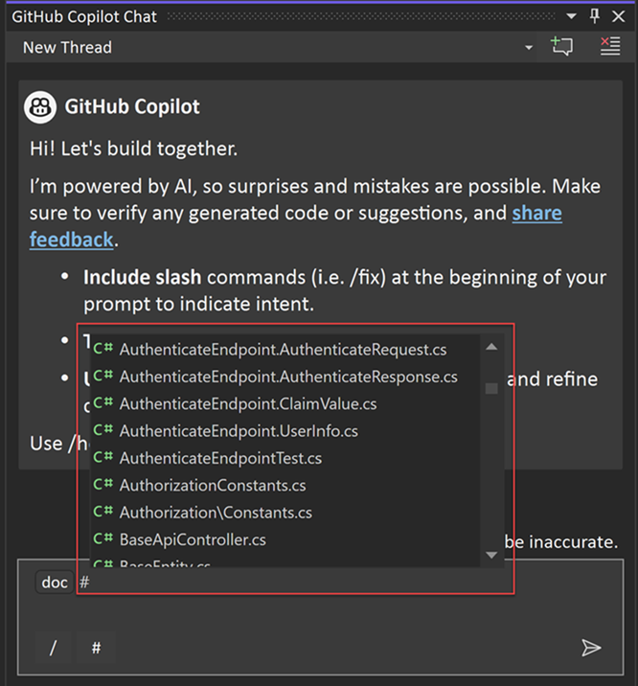  
  
To easily reference a file, simply add a # symbol at the beginning of the file name. For example, if you have a file named BasketService.cs, refer to it in the chat as #BasketService.cs. Here are some examples of using references for context control:  
  
View Sources Used by Copilot

Copilot Chat displays the context it used after every result, so that you can tell what was taken into account when answering your question. When you ask a Copilot Chat a question and get a response in the chat window, an **References** dropdown appears below the response. The entries in the **References** dropdown list show you the context referenced by Copilot Chat to generate that response. This information can help you modify your question to get better and more relevant answers.  
  
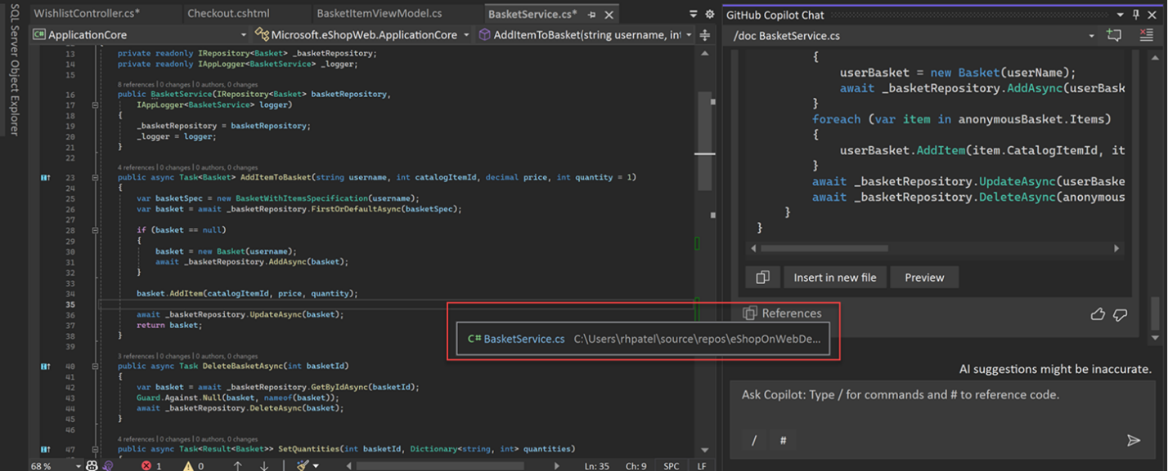

# Conclusion

Github Copilot is a powerful tool that can help you write better code faster. By installing the Github Copilot Chat extension on Visual Studio, you can chat with the AI and ask for code suggestions, documentation, tests, refactorings, and more. You can also use the extension to learn from the AI and improve your coding skills. Try it out and see how Github Copilot can boost your productivity and creativity.